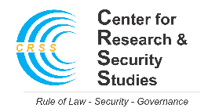
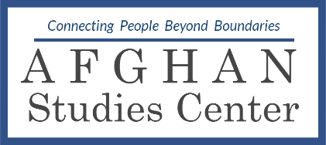
Pak-Afghan Youth Dialogue Series (PAYDS)
Application Form

Personal Details
Name: |  | Gender:

Father’s name:

Date of birth: |  | Nationality:

City: |  | Country:

Mobile:
Email:
Home address:

Academic/Professional Information
Qualification: |  |  | Degree Major:
Institute:
Country:
If currently enrolled (Degree/Institution):
Work experience (if any):
Position:
Organization:

Please limit your answers to 5 to 6 lines.
1. Why are you interested in joining the Pak-Afghan Youth Dialogue Series?

2. What contribution can you make to the program as a participant?

3. Have you been part of a youth program before? If so, please give details.
4. The venue for our dialogue series is usually Islamabad, Pakistan. Would you be able to travel to Islamabad on your own if you are selected?

I certify that the information given in this application is complete and accurate to the best of my knowledge.

Signature:
Date:

Please email the complete form with your CV at info@afghanstudiescenter.org.

